City of Bellevue
Community Development Block Grant

Community Development Block Grant Coronavirus Response (CDBG-CV)
Application
Guidelines & Forms
for projects within the Bellevue city limits

Applications Deadline:
4:30 p.m. at Monday June 1, 2020

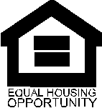
City of Bellevue
1500 Wall Street
Bellevue, NE 68005
(402) 293-3000
Table of Contents
CDBG-CV APPLICATION TIMELINE 3
CDBG-CV FUNDING GUIDELINES 4
Applicant Eligibility 4
Grant Term 4
Application Filing Procedures 4
PROJECT ELIGIBILITY OVERVIEW 5
CDBG National Objective 5
LMI BENEFIT DETERMINATION 6
Eligible Activities/Costs 6
Ineligible Activities/Costs 7
Consolidated Plan Priority & Goals 7
CDBG APPLICATION INSTRUCTIONS AND REVIEW PROCESS 8
Application Review 8
City Council Award of Funding 8
Environmental Review Requirements 9
CDBG Subrecipient Agreement 9
Reporting Requirements and Monitoring 9
CDBG-CV APPLICATION CHECKLIST 10
PUBLIC FACILITY/PUBLIC SERVICE/HOUSING PROPOSAL NARRATIVE 12
BUSINESS ASSISTANCE PROPOSAL NARRATIVE 18
OTHER CDBG-CV CERTIFICATIONS 24
CONFLICT OF INTEREST 25
Attachment B: Quick Guide to CDBG ELigible Activities to Support Infectious Diseases REsponse 26
Attachment C: CDBG Low/Moderate income CEnsus Tracts 28

CDBG-CV APPLICATION TIMELINE

May 15, 2020 | CDBG-CV Application Form and Guidelines are available at www.bellevue.net, under Quick links and on CDBG Department page.
June 1, 2020 | Application Deadline
June 1-5, 2020 | Staff review of Applications, packets distributed to the CDBG Committee for review.
June 10, 2020 | Notice of Availability of CDBG-CV Plan and Funding Recommendation for review.
June 16, 2020  Council Chambers, 1500 Wall Street,  Bellevue, NE 68005 | CDBG-CV Funding Recommendations presented to the Mayor and City Council members for review and hold public hearing
July 7, 2020  Council Chambers, 1500 Wall Street,  Bellevue, NE 68005 | Mayor and City Council hold public hearing and make final decision on CDBG-CV Funding Recommendation.
July 10, 2020 | Availability of Final CDBG-CV Plan and submittal to HUD for approval.

CDBG-CV FUNDING GUIDELINES
In response to the Coronavirus Pandemic (COVID19), the United States Department of Housing and Urban Development (HUD) through the Community Development Block Grant (CDBG) program has notified entitlement community they will receive a formula allocation from the first round of CDBG-CV funding to be used specifically for the prevention of, preparation for, and response to the COVID-19 Coronavirus. This allocation was authorized by the Coronavirus Aid, Relief, and Economic Security Act (CARES Act), Public Law 116-136, which was signed on March 27, 2020.
The City of Bellevue is accepting applications from non-profits and eligible applicants to help in the prevention of, preparation for, and response to the coronavirus. All applications must meet a CDBG eligible activity, national objective, and, must be associated with COVID-19 response.
HUD has provided maximum flexibility for the use of CDBG-CV funding by eliminating the typical CDBG percentage caps for which the amount of grant funds can be used. Therefore, funding may be utilized fully for public services, public facilities/housing, and economic development activities, or any combination thereof. Eligible CDBG-CV projects/programs must be within the city limits of Bellevue or provide services to Bellevue residents.
CDBG-CV grants will be subject to oversight, reporting, and requirements that each grantee have adequate procedures to prevent the duplication of benefits which means grant funds may not be used to pay costs if another source of financial assistance is available to pay that cost. Awarded subrecipients will be required to certify during the subrecipient agreement term that there is no supplanting of federal funds for requested projects/programs.
The City of Bellevue maintains the right to reject or accept applicants, to fund or not to fund, or to reduce the amount of funding requested.

Applicant Eligibility
Eligible applicants are limited to 501(c)(3) nonprofit organizations, government agencies, faith-based organizations (non-religious purposes), school districts, and, under limited circumstances, for-profit businesses (for-profit businesses, please check with the CDBG Program Administrator to determine eligibility).

Grant Term
The program period for CDBG-CV funding will run from March 1, 2020, through September 30, 2022. The term of a grant is generally for a 12-month period in order to meet HUD timeliness requirements; this may be extended for up to a one-year term only on a case-by-case basis.

Application Filing Procedures
Applications may be mailed or hand-delivered to the City of Bellevue and must be received no later than 4:30 p.m. on June 1, 2020. Applications received after 4:30 p.m. will not be considered for funding. It is the applicant’s responsibility to ensure that the application is received on time. There is no penalty for early submission.

PROJECT ELIGIBILITY OVERVIEW
The CDBG-CV funding provided through the Coronavirus Aid, Relief and Economic Security Act (CARES Act) has been provided to communities to use to prevent, prepare for, and respond to COVID-19. A CDBG-CV eligible activity quick guide provided by HUD is available in the attachments of this document. In addition to addressing COVID-19, eligible projects must also meet CDBG requirements of:
- Meet a CDBG national objective
- Qualify as an eligible activity.

CDBG National Objective
All activities proposed for funding must meet one of three national objectives:
- Activities benefiting low- and moderate-income (LMI) persons or households,
- Activities which aid in the prevention or elimination of slums or blight, or
- Activities designed to meet community development needs having a particular urgency
The primary objective of the CDBG program is to benefit LMI persons. Benefit to LMI persons can by designated by the following categories (1) area benefit, (2) limited clientele, or (3) employment/job opportunities.
Area Benefit Activities – Activities must benefit all residents in a particular service area, where at least 51% of persons in the service area are low- and moderate-income, as determined by HUD and the U.S. Census Bureau. The service area is determined based upon the nature of the activity, location of the activity, accessibility issues, availability of comparable activities, and boundaries for public facilities and public services. Service areas must be determined prior to provision of CDBG assistance. Examples of eligible activities include infrastructure, public facilities, and economic development.
Limited Clientele Activities – At least 51% of the beneficiaries of the proposed project activity must be low- and moderate-income and must satisfy one of the following criteria: (1) benefit a clientele that is generally presumed to be principally low- and moderate-income including abused children, battered spouses, elderly persons, severely disabled adults, homeless persons, illiterate adults, persons living with AIDS, and migrant farm workers, (2) document household size and income which demonstrates that at least 51% of the clientele are low- and moderate-income, (3) restrict income eligibility for the activity to low- and moderate-income persons, or (4) be of such a nature and in such a location that it can be concluded that clients are primarily low- and moderate-income.
Economic Development Activities – Activities must be undertaken with the purpose of creating or retaining permanent jobs, at least 51% of which (computed on a full-time equivalent basis) will be made available to or held by low-and moderate-income persons.
Housing Activities – Activities undertaken for the purpose of providing or improving permanent residential structures which, upon completion, will be occupied by at least 51% low and moderate-income households.

LMI BENEFIT DETERMINATION
To determine whether an individual or household can be considered LMI, the household size needs to be taken into consideration, and the total household income needs to be less than 80 percent of the local area median income. The current income guidelines as established by HUD are summarized in the following table:
Omaha-Council Bluffs NE-IA HUD Metro FMR Area
FY 2019 Income Limit Area | Income Limit Category | 1  Person | 2  Person | 3  Person | 4  Person | 5  Person | 6  Person | 7  Person | 8  Person
Omaha-Council Bluffs, NE-IA HUD Metro FMR Area | Extremely Low (30%) | $18,100 | $20,650 | $23,250 | $25,800 | $27,900 | $29,950 | $32,000 | $34,100
 | Very Low  (50%) | $30,100 | $34,400 | $38,700 | $43,000 | $46,450 | $49,900 | $53,350 | $56,800
 | Low (80%) | $48,200 | $55,050 | $61,950 | $68,800 | $74,350 | $79,850 | $85,350 | $90,850

Eligible Activities/Costs
Eligible activities may include, but are not limited to:
- Acquisition of real property;
- Demolition;
- Rehabilitation of residential and non-residential structures (must own building);
- Construction of public facilities and improvements, such as water and sewer facilities, streets, neighborhood centers, and the conversion of school buildings for eligible purposes;
- Public services (must be a new service or a quantifiable increase in the level of existing service);
- Activities relating to energy conservation and renewable energy resources; and
- Providing assistance to profit-motivated businesses to carry out economic development and job creation/retention activities.
Eligible activity costs may include:
- Direct personnel costs necessary to carry out the activity;
- Reasonable administrative costs relating to oversight of the activity (generally 10%);
- Materials and supplies necessary to the activity; and
- Rent, insurance, and utilities associated with the activity location.
HUD has released a guide to CDBG activities to support COVID-19 response. The quick guide can be found at Attachment A.

Ineligible Activities/Costs
Generally, the following types of activities are ineligible:
- Those activities not meeting a National Objective;
- Acquisition, construction, or reconstruction of buildings for the general conduct of government;
- Political activities
- Certain income payments; and
- Construction of new housing.
Generally, the following types of costs are ineligible for funding:
- Any costs not directly related to the implementation of the activity described in the approved application;
- Costs incurred prior to an executed subrecipient agreement or after the expiration of the CDBG subrecipient agreement; and
- Administrative costs that are considered excessive or unreasonable.

Consolidated Plan Priority & Goals
In accordance with federal requirements, the City of Bellevue developed a Consolidate Plan for 2019-2023 that outlines a five-year strategic plan describing how the City will used HUD funds to address CDBG program goals. The following priorities and goals were identified in the 2019-2023 Consolidated Plan to address needs in the community that were discussed in the planning process. Additional information is available in the Consolidated Plan document available on the City’s website.
Priority #1: Encourage Economic Development through Business Development and Job Creation. (HIGH) To promote business growth and development to increase job opportunities and revenue growth for the community as well as provide assistance for the development and expansion of employment opportunities and job training.
Priority #2: Improve and Expand the Availability and Accessibility to Public Infrastructure and Buildings. (HIGH) To rehabilitate, expand and improve infrastructure in established business and residential areas within city limits to promote and encourage redevelopment and reuse of available sites.
Priority #3: Increase Affordable Housing Opportunities. (HIGH) To maintain the availability and affordability of current housing market stock while researching and developing opportunities to expanding affordable housing opportunities through partnerships.
Priority #4: Increase and Expand Public Service Availability. (LOW) To provide support and assistance for the development and expansion of public service with community partners to address underserved needs in the community.
Priority #5: Administration of CDBG Program. (HIGH) To continue to maintain and administer a successful CDBG Program.

CDBG APPLICATION INSTRUCTIONS AND REVIEW PROCESS
Complete hard copy or electronic copy application packets will be accepted until June 1, 2020 at 4:30 p.m. local time. Late applications will not be accepted. It is important to note that social distancing efforts are in effect at all City locations and may affect the delivery of your application. Applications are encouraged to submit applications prior to the due date.
There are separate application narrative sections for public facility improvements/public service/housing and business assistance activities. Complete the narrative that meets your project description.
All application materials will become the property of the City of Bellevue. Strict adherence to these guidelines is required. It is the applicant’s responsibility to ensure the applications are complete and correct. Incomplete or incorrect applications will not be considered for funding.
A separate application should be submitted for each project or activity. If one organization is submitting more than one project/activity, a separate application must be submitted for each project. If more than one project/service is being requested from the same organization, a priority rating must be assigned to each project request – i.e. Priority #1, Priority #2, etc.
All applications must be signed by the Executive Director or an authorized officer of the organization.

Application Review
After the application deadline, CDBG staff will review each submitted application for completeness and for basic CDBG program eligibility and COVID-19 response. Those applications determined to be either incomplete or ineligible for funding will not be considered for funding and applicants will be called and notified as such. After the CDBG staff has completed the initial review, applications will be provided to the CDBG Committee for their review. During the next public hearing, a funding recommendation from the CDBG Committee and CDBG staff and draft CDBG-CV Action Plan Amendment will be presented to the Mayor and City Council for discussion and questions during the meeting scheduled for Tuesday, June 16, 2020 at 6:00 p.m.
The maximum points an application can receive will be 120. The CDBG staff will use these scores to create the order in which it considers funding recommendations. However, these scores will be a starting point, and the applicants may not be funded in order of rank.
It is the responsibility of the City of Bellevue to ensure that the CDBG-CV funds received are disbursed wisely and managed efficiently in the delivery of services that are most beneficial to the community. To fulfill this responsibility, the CDBG staff will conduct a thorough review of applicants and their applications for funding to evaluate operation, services, projects, and budgets.

City Council Award of Funding
The Bellevue City Council will consider the recommendations regarding funding requests at its meeting on June 16, 2020. In addition, a public hearing will be conducted at the same time to allow resident comment and input on the proposed activities. The City Council will conduct another public hearing and make its final decision regarding funding requests at the July 7, 2020, regularly scheduled City Council meeting.
Those activities approved for funding by the City Council will be included in a substantial amendment to the City’s approved 2019 Action Plan and submitted to HUD for its review.

Environmental Review Requirements
Following approval by Bellevue City Council, the City of Bellevue will begin the environmental review of each project. As part of CDBG requirements prior to the Release of Funds, an Environmental Review Record must be completed. If the project does require an environmental assessment, the applicant will be asked to provide the City of Bellevue with all available environmental information about the project and any information in connection with the conduct and preparation of environmental review. The applications will be responsible to provide any investigations or studies needed to fulfill its obligation under HUD environmental review requirements and to cover any cost incurred to complete the appropriate reports or studies. The Environmental Review Record and Release of Funds must be complete prior to the expenditure or commitment of program funds.

CDBG Subrecipient Agreement
Following the City Council’s approval of the CDBG-CV activities, environmental review record completion and execution of a HUD Funding Agreement, staff will prepare subrecipient agreements for all approved activities. Each agreement will contain the terms and conditions of the CDBG funding, a description of the approved activity and costs, outline of all federal regulations and will specify applicable City insurance requirements including comprehensive general liability, workers’ compensation, and vehicle coverage. Agreements will also include the measurable objectives and accomplishment data that must be reported. The person designated by resolution will be required to sign the CDBG agreement and return it to the City of Bellevue. All agreements will then be approved by the City Council. Prior to agreements being executed, all subrecipients are highly encouraged to thoroughly review the agreement and accomplishment reporting forms and schedule a meeting with the CDBG Program Administrator as necessary.

Reporting Requirements and Monitoring
Note that it is City of Bellevue’s responsibility to ensure all entities receiving CDBG funds are in compliance with HUD regulations. Recipients must provide all information requested to assist with documentation in a timely manner.
CDBG subrecipients shall be required to submit a monthly or quarterly progress report regarding the funded activity. The format of these reports will be described in the CDBG subrecipient agreement. The City of Bellevue may request additional reporting from a subrecipient. Noncompliance could result in suspension or termination of the agreement and reallocation of the CDBG funds. Noncompliance will also be considered when applicants request future funding.

CDBG-CV APPLICATION CHECKLIST
All requests for funding must include the following documents to be considered for funding. Please note the scoring criteria as you complete the application. All information is required even if no points are specifically assigned. Incomplete applications will not be considered.
Check next to each form that is included in this application:
- Application Narrative
- Cover Sheet
- Proposal Narrative (Public Facility/Public Service/Housing Narrative or Business Assistance Narrative)
- Introduction
- Need
- Project Effectiveness – Including Performance Outcome Measurement Spreadsheet
- Cost Effectiveness – Including Budget Itemization Sheet
- Conflict of Interest Statement
- Other CDBG-CV Certifications

- Non-Profit - Required Attachments
- List of Board of Directors
- Organizational Chart
- Resume of program administrator
- Resume of fiscal officer
- Tax Exemption Determination Letter
- Articles of Incorporation
- By-Laws
- Equal Opportunity Employment statement & Grievance Procedure
- Financial statement and/or most recent audit
- Audit Requirements (if applicable)
- Statement of Insurance
- Other CDBG-CV Certification

- Business - Required Attachments
- List of Business Stakeholders
- Completed IRS-W (W-9 Form)
- Equal Opportunity Employment statement & Grievance Procedure
- Financial statement and/or most recent audit
- Statement of Insurance
- Business Plan
- Other CDBG-CV Certification
- Attachment B: Business Applicant Information

- Application must be submitted by hard copy or electronic copy by 4:30 p.m. on June 1, 2020.

City of Bellevue
CDBG-CV application for assistance

Due: June 1, 2020, at 4:30 P.M. No late or incomplete applications will be accepted

Application Cover Sheet
AGENCY NAME & ADDRESS | CONTACT INFORMATION: NAME, TITLE, EMAIL, & PHONE #
PROJECT TITLE:
PROJECT LOCATION OR BOUNDARIES:
PROJECT PRIORITY: If your agency submits more than one CDBG application, pleases rank the priority.
This project is ranked _ __ of __ ___ CDBG project applications.
PROJECT FUNDING REQUESTED |  | IDENTIFICATION NUMBERS
CDBG-CV FUNDS REQUESTED: $
APPLICANT FUNDS: $ |  | DUNS #:
OTHER FUNDS (Specify):
$ |  | CCR #:
TOTAL PROJECT COST: $
PERCENTAGE OF CDBG-CV INVESTMENT %
(CDBG-CV Amount Requested/Total Program Cost)
CERTIFICATION
I certify that the applicant agency meets the conditions specified in the application instructions and will be able to carry out the proposed services in concert with all federal requirements. I also certify that the organization is a certified IRS 501(c) (3) non-profit or governmental agency. I agree to adhere to the above provisions for all programs receiving assistance from the US Department of Housing & Urban Development. All board and staff members have disclosed any potential conflicts of interests that could violate CDBG Program regulations at this time or at a later date. I further certify that I have reviewed the contents of this application and the rating form and deem them to be accurate and true.
ACKNOWLEDGED RESPONSBILITY TO ABIDE BY ALL HUD AND CITY OF BELLEVUE REQUIREMENTS
The applicant agrees to abide by all policies, regulations, ordinances, or statutes as required by HUD and City of Bellevue. Please select the following link to comprehensively review the CDBG regulations: 24 CFR 570.
Yes No
Typed Name and Title of Authorized Representative:
Signature of Authorized Representative: _______________________________________________
Date Signed: ____________________________________________________________________

PUBLIC FACILITY/PUBLIC SERVICE/HOUSING PROPOSAL NARRATIVE
**Please leave Score Column blank** **Fully answer each question to earn maximum possible points**

Score | Introduction: Organizational InformatioN
 | Please provide the Background & Experience of the Organization: Including a brief history of the organization, the organization’s mission statement, the length of time the organization has been providing services, and the type of legal structure (i.e. 501(c)(3) nonprofit, partnership, etc.).
 | Has the applicant carried out services/programs/projects similar in nature to the proposed service/program/project? Yes No
 | This project is eligible under which HUD Eligible Activity listed below:
Public Facility and Improvements Public Service

Economic Development Housing

Other

 | This project meets which of the HUD National Objectives listed below:
Benefits low/moderate income individuals, area, or households.

Addresses the prevention or elimination of slums or blight.

Meets a particularly urgent community development need.

 | Describe your project and its response to COVID-19, including the exact use for the requested CDBG-CV funds.

(35Points) | Section 1: Project Need and Justification  This section includes a narrative explaining need, target areas, and population served.
(15pts) | What need in the community is there for the project? Provide a concise summary of the need for the project and how it will address COVID-19 response. Utilize community statistics, demographics or other factual information to demonstrate the unmet need.
(3pts) | Does the project address Consolidated Plan priorities? Identify the priority and explain specifically how the project will meet the priority. (See Attachment A)
(3pts) | Indicate the location (target service delivery area) in which the program/activity will be completed or carried out. Indicated if the activity specifically serves a Low/Mod Census Tract. A map may be included to demonstrate project area. (See Attachment C)
(8pts) | Briefly describe the target population/category of persons to be served in the City of Bellevue. Provide the anticipated unduplicated number of households/persons to be assisted and how you determined this estimate. Use the Annual Income Limit Table to assist with identifying the number for each income level of the proposed audience: very low –income, low-income, and moderate-income. (See Attachment B)
(6pts) | What documentation will be used to prove the funds are going to the prevention, preparation, or response to the Coronavirus?

(40Points) | Section 2. Project Effectiveness  This section should include the narrative, the performance outcome measurement spreadsheet and a project timeline.
(16pts) | Using the performance outcome measurement spreadsheet, describe the activity’s proposed accomplishment. Items to consider: what methods will be used to evaluate the success of the project and whether outcomes were accomplished? This should include specific and measurable outcomes of the project and be identified on the provided spreadsheet.
(8pts) | Describe the steps that have been completed or must be completed to initiate the project. These may include securing an appropriate location, marketing, and networking. Include the project’s timeline with dates and times, including the earliest possible start dates, end dates, and milestones as applicable. Be as specific as possible.
(8pts) | Describe the organization's staff positions and qualifications as it relates to the project including how many staff persons are dedicated to this project, if new staff will be added, does the organization have administrative staff that will dedicate time to this project, has the organization secured funding for staff needed for this project.
(8pts) | Describe how the planning and operation of this project has been coordinated with other public agencies and the community to avoid duplication of service. Describe any community outreach and/or collaborations and attach supporting documentation, i.e. letters of support, collaboration.

Section 2 Attachment: Performance Outcome Measurement Spreadsheet
- Objective: Select the goal which the program/project will meet.
Create a Sustainable Living Environment | Provide Decent Housing | Create Economic Opportunity
Designed to benefit communities, families, or individuals by addressing issues in their living environment, i.e. poor infrastructure, social issues such as crime prevention, fair housing, youth or elderly services. | Purpose of the program is to meet individual, family, or community housing needs, i.e. | Objective applies to the types of activities related to economic development, commercial revitalization, or job creation.
GOALS – Briefly describe future expected outcome of the activity.
OUTPUTS - The quantifiable products of an organization’s activities. They are measurements of the amount of work accomplished. Examples would include the number of low- and moderate-income persons served, the number of households served. Connect each output with the activity listed above.
- OUTCOME: Select the most appropriate outcome for the program/project activity. Outcomes are produced during or after their involvement in an activity.
Improve Availability/ Accessibility | Improve Affordability | Improve Sustainability
Activities that make services, infrastructure, public facilities, housing, or shelters available or accessible to low- and moderate-income people, including persons with disabilities. | Activities that provide affordability in a variety of ways in the lives of low- and moderate-income people, i.e. creation or maintenance of affordable housing, basic infrastructure hookups, or services such as transportation. | Activities where the aim is to improve neighborhoods, helping to make them livable or viable by providing benefit to persons of low and moderate income or by removing or eliminating slums or blighted areas.
OUTCOME MEASUREMENT – Describe evaluation tools methods and benchmarks to measure achievements of the outcome. (i.e. client surveys, statistical data from verifiable source).

(45Points) | Section 3. Cost Effectiveness/Budget  This section should include both a narrative and a completed budget itemization sheet.
(20pts) | Using the itemized budget sheet provide below, complete a budget that is sufficiently detailed to determine that proposed expenditures are reasonable. More detailed budgets may be attached.
(5pts) | Provide details for equipment, services, and supplies requested (i.e., rental of Xerox machine, computer paper). There should be little to none non-specific costs, such as overhead and miscellaneous (i.e., rent, insurance). If you have included any, provide a compelling narrative justification for costs.
(7pts) | Provide an administrative cost ratio (administrative costs ÷ total project costs). Please explain any extenuating circumstances that affect these estimates, such as specialized equipment, intensity of counseling required, etc.
(8pts) | The City encourages CDBG funds be used as gap funding and leveraging. Identify sources of leveraged funding for this activity. Include the status of these funds (i.e. cash on hand, grants receive, planned fundraising). Attach any supporting documentation.
(5pts) | If only partially funded (portion of the requested amount), will you be able to proceed with the project? Please highlight how that would affect the project scope.

Section 3 Attachment: Budget Itemization Spreadsheet

 |  |  |  | Other Sources (Specify-List)
BUDGET CATEGORIES | Budget Narrative (Details) | Total Project Cost | City of Bellevue CDBG-CV Funds Requested | Funds Committed: | Funds Committed: | Funds Committed: | Funds Committed:
 |  |  |  | Yes  No | Yes  No | Yes  No | Yes  No
PROGRAM COSTS
PERSONNEL COSTS
TOTAL COSTS |  | $ | $ | $ | $ | $ | $

BUSINESS ASSISTANCE PROPOSAL NARRATIVE
**Please leave Score Column blank** **Fully answer each question to earn maximum possible points**

Score | Introduction: Business InformatioN
 | Please provide the Background & Experience of the Business: Including a brief history, the length of time the business has been providing services, and the type of legal structure.
 | Has the business carried out services/programs/projects similar in nature to the proposed service/program/project? Yes No
 | This project is eligible under which HUD Eligible Activity listed below:
Public Facility and Improvements Public Service

Economic Development Housing

Other

 | This project meets which of the HUD National Objectives listed below:
Benefits low/moderate income individuals, area, or households.

Addresses the prevention or elimination of slums or blight.

Meets a particularly urgent community development need.

 | Describe your reason for requesting CDBG-CV in response to COVID-19, including the exact use for the requested CDBG-CV funds.

(35Points) | Section 1: Business/Staffing Information
(15pts) | Provide a description of how CDBG-CV funds will be used, including how they will impact your business operations. Include a description of how your business has been affected by COVID-19 restrictions including, but not limited to, any reduction in staff, furloughs, layoffs, or closures.
(8pts) | Does the project address Consolidated Plan priorities? Identify the priority and explain specifically how the project will meet the priority. (See Attachment A)
(3pts) | Indicate the location (target service delivery area) of your business and the service area. Indicated if the business specifically serves a Low/Mod Census Tract. A map may be included to demonstrate project area. (See Attachment C)
(3pts) | Describe your staffing levels and the effects of COVID-19 on current staffing levels, i.e. levels prior to the Governor’s Direct Health Measure and current levels for number of employees and number of low- and moderate-income employees.
(6pts) | What documentation will be used to prove the funds are going to the prevention, preparation, or response to the Coronavirus?

(40Points) | Section 2. Project Effectiveness  This section should include the narrative, the performance outcome measurement spreadsheet and a project timeline.
(16pts) | Using the performance outcome measurement spreadsheet, describe the activity’s proposed accomplishment. Items to consider: what methods will be used to evaluate the success of the project and whether outcomes were accomplished? This should include specific and measurable outcomes of the project and be identified on the provided spreadsheet, i.e. number of low- to moderate-income employees retained or rehire, number of new hires, and/or increased hours of operation.
(8pts) | Describe the steps that have been completed or must be completed to initiate the project. These may include securing an appropriate location, marketing, and networking. Include the project’s timeline with dates and times, including the earliest possible start dates, end dates, and milestones as applicable. Be as specific as possible.
(8pts) | Describe the business’ staff positions and qualifications who will be responsible for overseeing the management of CDBG-CV funding. Briefly describe their roles and experience in managing the personnel and financial aspects of the business.
(8pts) | Briefly describe the pre-development activities that have already been undertaken with respect to COVID-19 response.

Section 2 Attachment: Performance Outcome Measurement Spreadsheet
- Objective: Select the goal which the program/project will meet.
Create a Sustainable Living Environment | Provide Decent Housing | Create Economic Opportunity
Designed to benefit communities, families, or individuals by addressing issues in their living environment, i.e. poor infrastructure, social issues such as crime prevention, fair housing, youth or elderly services. | Purpose of the program is to meet individual, family, or community housing needs, i.e. | Objective applies to the types of activities related to economic development, commercial revitalization, or job creation.
GOALS – Briefly describe future expected outcome of the activity.
OUTPUTS - The quantifiable products of an organization’s activities. They are measurements of the amount of work accomplished. Examples would include the number of low- and moderate-income persons served, the number of households served. Connect each output with the activity listed above.
- OUTCOME: Select the most appropriate outcome for the program/project activity. Outcomes are produced during or after their involvement in an activity.
Improve Availability/ Accessibility | Improve Affordability | Improve Sustainability
Activities that make services, infrastructure, public facilities, housing, or shelters available or accessible to low- and moderate-income people, including persons with disabilities. | Activities that provide affordability in a variety of ways in the lives of low- and moderate-income people, i.e. creation or maintenance of affordable housing, basic infrastructure hookups, or services such as transportation. | Activities where the aim is to improve neighborhoods, helping to make them livable or viable by providing benefit to persons of low and moderate income or by removing or eliminating slums or blighted areas.
OUTCOME MEASUREMENT – Describe evaluation tools methods and benchmarks to measure achievements of the outcome. (i.e. client surveys, statistical data from verifiable source).

(45Points) | Section 3. Cost Effectiveness/Budget  This section should include both a narrative and a completed budget itemization sheet.
(20pts) | Using the itemized budget sheet provide below, complete a budget that is sufficiently detailed to determine that proposed expenditures are reasonable. More detailed budgets may be attached.
(7pts) | Provide details for equipment, services, and supplies requested. There should be little to none non-specific costs, such as overhead and miscellaneous (i.e., rent, insurance). If you have included any, provide a compelling narrative justification for costs.
(10pts) | List all funding sources that the business may apply for, have applied for, or have received due to COVID-19. Attach any documentation you would like to include.
(8pts) | If only partially funded (portion of the requested amount), will you be able to proceed with the project? Please highlight how that would affect the project scope.

Section 3 Attachment: Budget Itemization Spreadsheet

 |  |  |  | Other Sources (Specify-List)
BUDGET CATEGORIES | Budget Narrative (Details) | Total Project Cost | City of Bellevue CDBG-CV Funds Requested | Funds Committed: | Funds Committed: | Funds Committed: | Funds Committed:
 |  |  |  | Yes  No | Yes  No | Yes  No | Yes  No
PROGRAM COSTS
PERSONNEL COSTS
TOTAL COSTS |  | $ | $ | $ | $ | $ | $

OTHER CDBG-CV CERTIFICATIONS
Overall Benefit: The business entity certifies that the CDBG-CV funds awarded by the City of Bellevue will be used only for the benefit of employees affected by COVID-19 and who are Bellevue residents – those residing within the actual City Limits of Bellevue – and that at least 70% of those receiving benefit are low- to moderate-income employees.
Compliance with Anti-discrimination laws: The programs funded in part or totally by CDBG-CV will be conducted and administered in conformity with Title VI of the Civil Rights Act of 1964, the Fair Housing Act (42 USC 3601-3619, and implementing regulations, as amended.
Affirmatively Furthering Fair Housing: The business entity will take appropriate actions when applicable to overcome the effects of any impediments identified through the City’s Analysis of Impediments to Fair Housing Choice and maintain records reflecting the actions taken.
Anti-displacement and Relocation Plan: In the event that the business entity conducts housing acquisition, demolition or rehabilitation with CDBG-CV funds that require the relocation of residents, the business entity will comply with the Uniform Relocation Assistance and Real Property Acquisition Policies Act of 1970, as amended, and the regulations at 49 CFR 24; and it has in effect and is following a residential anti-displacement and relocation assistance plan as required under section 104(d) of the Housing and Community Development Act of 1974, as amended, in connection with any activity assisted with funding under the Bellevue CDBG-CV program.
Lead-Based Paint: Any activities concerning lead-based paint will comply with the requirements of part 34, subparts A, B, J, K and R of Title 24 of the Code of Federal Regulations.
Compliance with Laws: The entity will comply with all applicable local, state and federal laws.

___________________________________ ____________________________
Signature Date

_________________________________
Printed Name and Title

CONFLICT OF INTEREST

Federal Law (24 CFR 570.611) prohibits persons who exercise or who have exercised any functions or responsibilities with respect to the Community Development Block Grant…or who are in the position to participate in a decision making process or to gain inside information with regard to such activities, may obtain a financial interest or benefit from an assisted activity…either for themselves or those whom they have family or business ties, during their tenure or for one year thereafter.

I hereby certify to the best of my knowledge and belief that no staff member, member of the Board of Director’s, nor officer of (agency) is currently, nor has been within one year date of this application, employed by the City of Bellevue, a member of the Community Development Block Grant (CDBG) Committee, nor a member of the Bellevue City Council.
I further attest that no staff member, member of the Board of Director’s, nor officer of the applicant agency, is a business partner or immediate family of a City employee, a member of the Community Development Block Grant (CDBG) Committee, or a member of the Bellevue City Council.
Funds requested will not be used to pay the salaries of any of the applicant agency’s staff who is or has been within one year of the date of this application a City employee, a member of the Community Development Block Grant (CDBG) Committee, nor a member of the Bellevue City Council. Nor will the applicant agency award a subcontract to any such individual.

Name: Title:

Signature: Date:

Attachment B QUICK GUIDE TO CDBG ELIGIBLE ACTIVITES TO SUPPORT CORONAVIRUS DISEASE RESPONSE
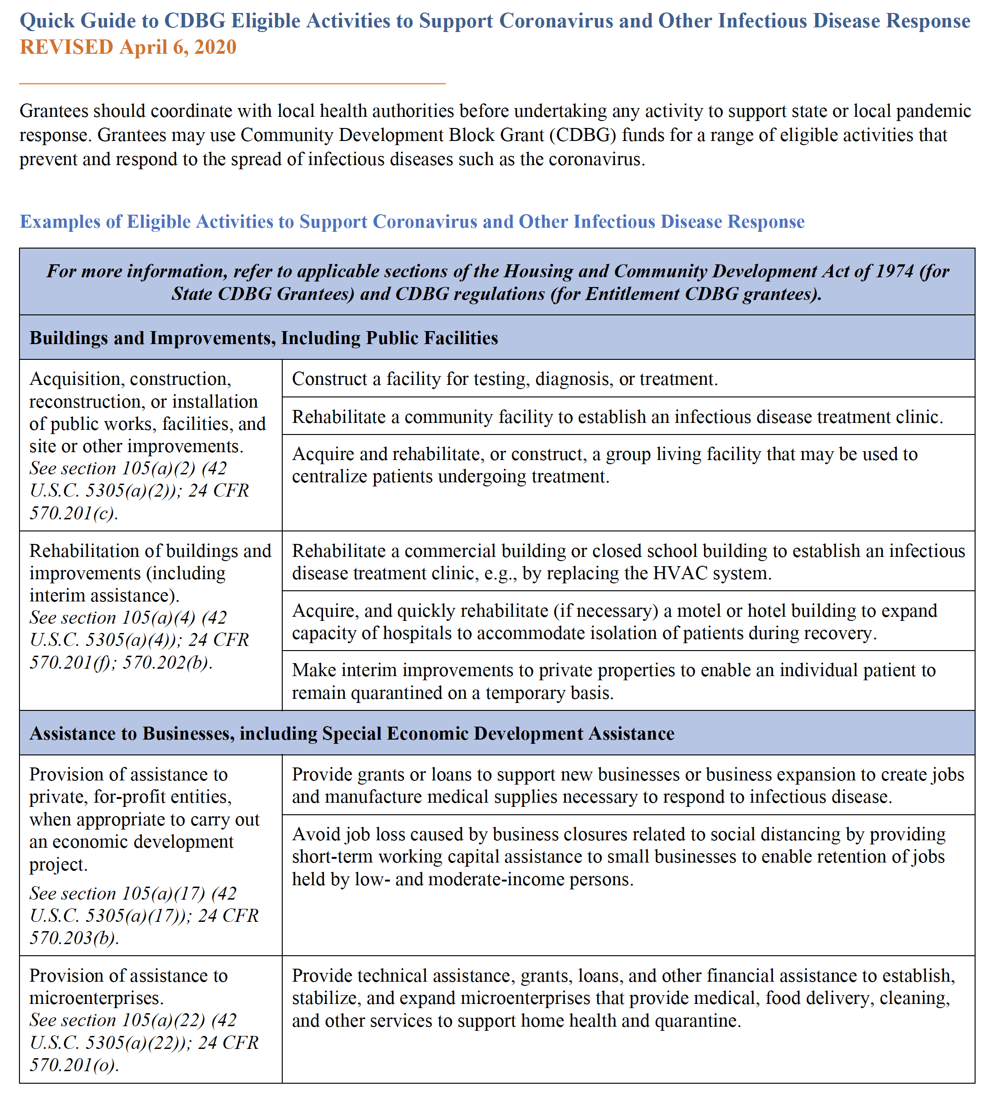
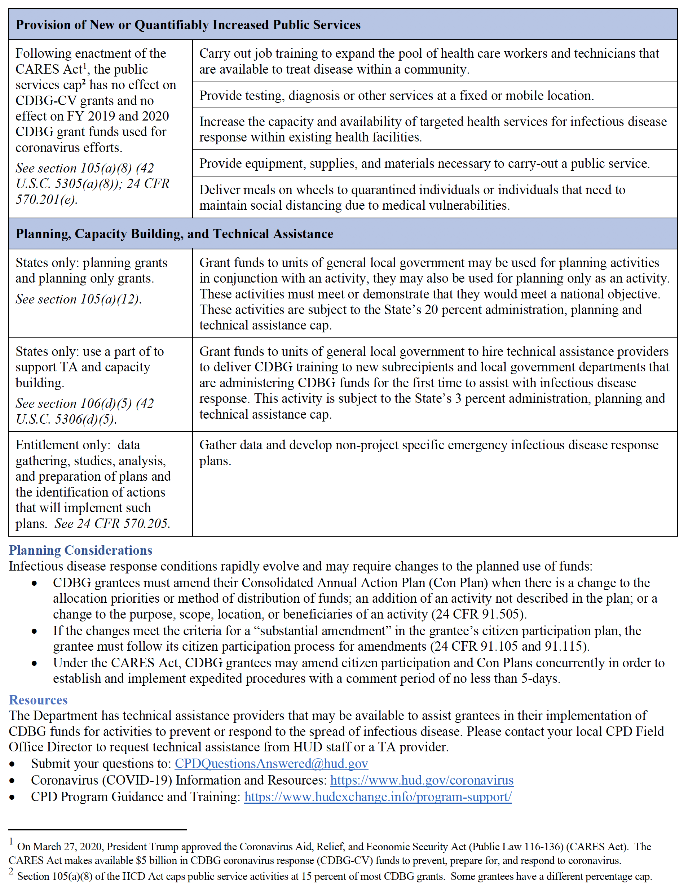

Attachment C: CDBG Low/Moderate income CEnsus Tracts
